ITTF – Para Table Tennis Division
T-Shirts for the World Championships
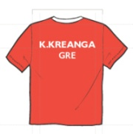 | World Championships  Please see the wording of the rule below and the sample of the shirts.
"Clothing and equipment worn or used by table tennis players in the Championships must comply with ITTF Rules. This is NOT mandatory for the other participants.
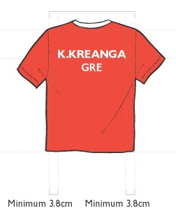
Each player must have with him/her at least two sets of shirts in different colors. The name of the player (first letter(s) of given names + complete family name) and the three letters code of his/her NF must be printed on the back of each shirt, included in the upper 1/3 of the shirt’s height.

