ATTC Classification Seminar in Cuba Report

Cienfuegos, Cuba
June 2004

Leandro Olvech
ATTC – Chairperson
IPTTC – Americas Rep.

ATTC Classification Seminar in Cuba Report

Date: June 24th to 28th 2004
Place: Cienfuegos, Cuba
Organization:
- Americas Table Tennis Committee for the disabled (ATTC)
- International Paralympic Table Tennis Committee (IPTTC)
- Instituto Cubano de Deportes, Educacion Fisica y Recreacion (INDER)

Lecturer: Prof. Nadia Vaccaro (ARG), IPTTC International Classifier

The seminar was held in the context of the Cuban national table tennis championships.
Classifiers, coaches, physical education teachers, managers and umpires have participated, being a total of 25 people.
It is important to outline the federalism of the seminar, representatives from 11 of the 14 provinces of the island were there.
ATTC Chairperson, Mr. Leandro Olvech assisted with the event with the aim to help promote table tennis in Cuba and the Caribbean, As a result of this visit there was an agreement of two goals in short and medium term to achieve:
- The organisation of an international IPTTC sanctioned tournament next year, for which the inspection was already done.
- To realize a coaching seminar for the Caribbean region

40 players from 12 provinces participated in the national championships with a special delegation from Venezuela with 4 players.

RELATIONS WITH TABLE TENNIS OF ABLED BODY

I had the opportunity to met different people from the Cuba sport Among them,Mr. Reinerio Fonseca Montoya the Chairperson of the Table Tennis Federation of Abled Body it is important to outline the good level of cooperation in between this organization and the Cuban Federation of sports for the disabled. The TT Federation of abled body is responsible in the disabled national championships of the technical issues like Tables, surrounders, nets and human resources. There were 4 umpires with ITTF regional level.

SPORTS MATERIALS

There is in Cuba an incredible lack of sport materials. The training balls cost there more than 1USD each, and to estimate the relative cost in the country we can compare it with the basic salary in Cuba of about 8USD per month.
One of the organisers from Cienfuegos, Mr. Manuel Castellanos, is also the director of sport industry in the province. He introduced me the responsible of a new project to develop national rackets, nets, tables and balls, this work is made by a private company in cooperation with government.
They had very good results with the new rackets in two versions, with or without pimples. I did not have the chance to see the tables but the nets and post are very good. About the balls they reported a lot of problems to enhance them.This national material will be used for development, and financed selling tables to be used for tourists (hotels, parks, etc)
ATTC made a small donation of special rackets to teach and balls.
It is necessary to emphasize also the effort made by the authorities of the national INDER and its department of Cienfuegos and the people from Asociación Cubana de Limitados Físico-Motores (ACLIFIM)

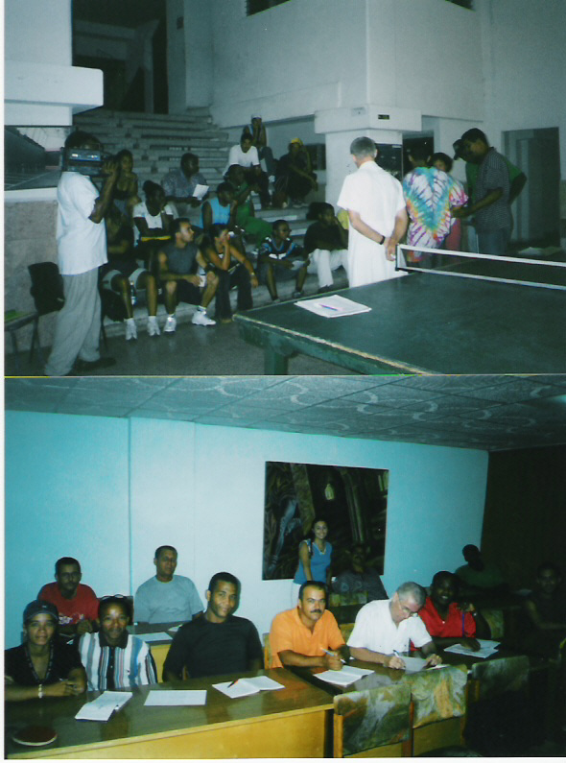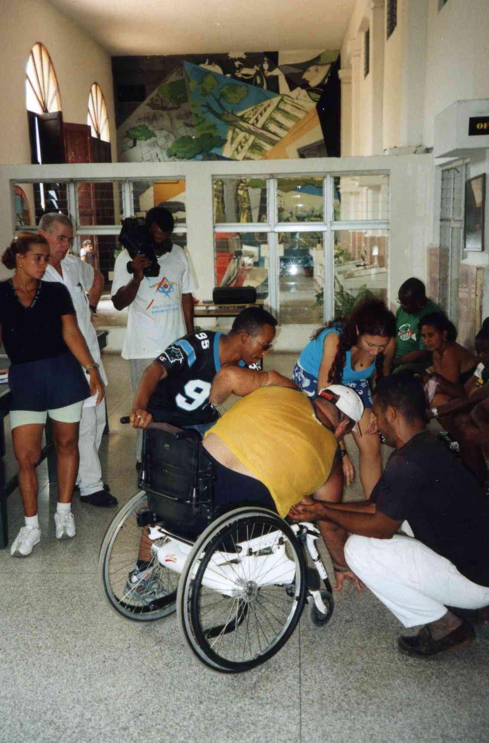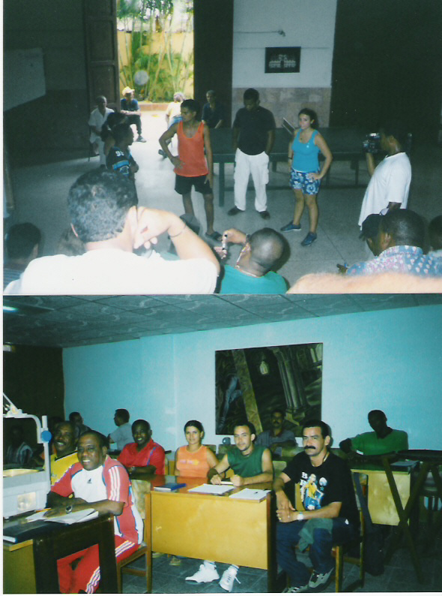

ATTC is the regional committee of Americas, recognized by IPTTC. Some of its functions are: to coordinate the biennial organisation of the table tennis Pan-American Championships, reporting and orientating to the National Paralympic Committees (NPC) and to work for the development of the region.

Leandro M. Olvech
ATTC – Chairperson
IPTTC – Americas Rep.
Americas.rep@ipttc.org
www.ipttc.org

 | Participants Report Form
Nr. | Name and Surname | Age | Province | Position | e-mail | Disabled
 | Nadia Brenda Vaccaro | 24 | Argentina | Lecturer | nadia_vaccaro@hotmail.com
1 | Antonio Nuñez Verdecia | 49 | Cuba | Manager | defe@inder.co.cu
2 | Roberto Panfet Caballero | 50 | Cuba | Manager | defe@inder.co.cu
3 | Angel M. Arteaga Martínez | 42 | Pinar del Rio | Manager | pnr@inder.co.cu | Yes
4 | Juan M. Gómez Quiñones | 39 | Pinar del Rio | Trainer | pnr@inder.co.cu
5 | Jorge L. Aponte Rodríguez | 42 | Prov. Habana | Manager | defe@inder.co.cu
6 | Mercedes Hernández Kindelan | 36 | Prov. Habana | Technical Director | hab@inder.co.cu
7 | Pedro Soto Alvarez | 37 | Ciudad Habana | Umpire | cha@inder.co.cu
8 | Adalberto Corrales Gil | 41 | Cienfuegos | Doctor | cfg@inder.co.cu
9 | Gustavo Hernández Vega | 41 | Cienfuegos | Trainer | cfg@inder.co.cu
10 | Yoel Alvarez Rodríguez | 28 | Cienfuegos | Umpire | cfg@inder.co.cu
11 | Leosvany Lara Hernández | 27 | Cienfuegos | Trainer | cfg@inder.co.cu
12 | Gustavo Tang González | 37 | Cienfuegos | Technical Director | cfg@inder.co.cu
13 | Manuel Castellanos Gutierrez | 45 | Cienfuegos | Manager | cfg@inder.co.cu
14 | Yunisley Rodríguez Pedroso | 26 | Villa Clara | Technical Director | vcl@inder.co.cu
15 | Omar González Lozano | 48 | Las Tunas | Manager | ltu@inder.co.cu
16 | Jorge L. Batista Rodríguez | 43 | Holguín | Manager | hlg@inder.co.cu
17 | Jorge Mustelier Gutierrez | 33 | Guantánamo | Umpire | gtm@inder.co.cu
18 | Yordanys Gago Rodríguez | 31 | Guantánamo | Athlete | gtm@inder.co.cu | Yes
 | Certificate of Participation
Nr. | Name and Surname | Age | Province | Position | e-mail | Disabled
1 | Maria Rosa Moreno Sánchez | 33 | Granma | Technical Director | gra@inder.co.cu
2 | Yureini Cedeño Ramirez | 27 | Granma | Technical Director | gra@inder.co.cu
3 | Carlos Martí Dieguez | 28 | Granma | Trainer | gra@inder.co.cu
4 | Cristino Santiago Alarcón | 62 | Camaguey | Manager | cmg@inder.co.cu
5 | Yolanda Ferrer Pontigo | 41 | Ciego de Avila | Technical Director | cav@inder.co.cu
6 | Elkin Ferrer Pontigo | 35 | Ciego de Avila | Trainer | cav@inder.co.cu
7 | José Gallardo Pérez | 48 | Ciego de Avila | Manager | cav@inder.co.cu

