1st ATTC SEMINAR REPORT
Buenos Aires, September 23rd to 29th, 2002
SEMINARS OFFERED:

- Umpires Seminar (Able body and disabled Table Tennis)
Monday 23rd- Tuesday 24th
Venue: La Matanza National University Auditory (UNLM)
Lecturer: Prof. Fernando Minc, ITTF International Umpire
University professor of Physical Education
Title: ATTC and FATM Umpire

- Table Tennis Functional Classification Seminar
Wednesday 25th -Thursday 26th
Venue: La Matanza National University Auditory (UNLM)
Lecturers: Ms. Nadia Vaccaro, ITTC Regional Classifier
Ms. Cintia Mariño, ITTC Trainee Classifier
Argentine Wheelchair Sport Federation, Table Tennis Committee (CTM – FADESIR) Classification Officers
Title: ATTC Classifier “A”

- Introduction to the Sports for the Disabled Seminar
Friday 27
Venue: La Matanza National University Auditory (UNLM)
Lecturers: Prof. Marcelo Olleac
Sports for the disabled International representative
UNLM Special Physical Education extension Boss

- Coaching Seminar
Saturday 28th
Venue: La Matanza National University Auditory and Gymnasium(UNLM)
Sunday 29th
Venue: Centro de Discapacitados de La Matanza (CEDIMA) Training Gym
Lecturers: Benedito Rodríguez of Olivera, HEAD COACH
Brazilian Paralympic Team Atlanta ´96, Sydney ´00
ATTC Vice-Chairman
Prof. Alejandra Gabaglio, HEAD COACH
Argentine Paralympic Team Sydney ´00
IPC World Table Tennis Championships Taipei ´02
Olympic Player Barcelona ´92
Mr. Leonardo Mariño, COACH
Argentine Paralympic Team Atlanta ´96,Sydney ´00
IPC WTTC Paris ´98, Taipei ´02
ATTC Development Officer
CTM – FADESIR Development Officer
Mr. Alejandro Ceccati, COACH
Argentine Paralympic Team Atlanta ´96, Sydney ´00, IPC WTTC Taipei ´92
CTM-FADESIR Tournament Officer
Mr. Leandro Olvech, COACH
Parapanamericano ´95, ´99 IPC WTTC Paris ´98
ATTC Chairman
CTM-FADESIR Chairman
Title: ATTC Coach Level “A”
Each participant received: 1 book for each seminar / certified diploma / informative portfolio, table tennis material, snacks and drinks in the breaks.

The participation was opened to: Physical Education Professors and Students, Educational of all the levels, NGOs, Sport Clubs, Table Tennis people in general and to all the interested in the development of the sport for the disabled.

It was not excluding not to have previous formation in table tennis

The seminars had the support of the following entities:

ITTC - International Table Tennis Committee
ATTC - Americas Table Tennis Committee for the disabled
APC - Americas Paralympic Committee
La Matanza Sports, Culture and Tourism Secretary
National Tourism and Sports Secretary
COPAR – Argentine Paralympic Committee
FADESIR – Argentine Wheelchair Sports Federation
FATM - Argentine Table Tennis Federation
FETEMBA - Buenos Aires Table Tennis Federation
CPB – Brazilian Paralympic Committee
CBTMA – Brazilian Table Tennis for the Disabled Confederation

Special guests:

- Prof. Héctor Ramírez – COPAR Chairman (Argentine Paralympic Committee)
- Mr. Rubén Palacios - FATM Chairman (Argentine Table Tennis Federation)
- Mrs. Inés del Gaudio - FADESIR Chairperson (Argentine Wheelchair Sports Federation)
- Mr. Marcos Lanusse - FADEPAC Chairman (Argentine Cerebral Palsy Sports Federation)
- Mr. José Córdoba - FADDIM Chairman (Argentine ID Sports for Federation)
- Alejandra Gabaglio – FADESIR Argentine Paralympic Team Head Coach
- Alejandro Ceccati - FADESIR Argentine Paralympic Team Coach
- Gustavo Levisman - FATM Argentina National Team
- Gabriel Copola - Paralympic Athlete - FADESIR
- Victor Brandoli - Paralympic Athlete - FADESIR
- Natalia Pugliese - Paralympic Athlete - FADESIR
- Luis Ferreira - Paralympic Athlete - FADESIR
- Daniel Haylan - Paralympic Athlete - FADESIR
- Ricardo Perdiguero - Paralympic Athlete-FADESIR
- Alejandra Satriani - Pre-selection Athlete-FADESIR
- Daniel Cañete - Pre-selection Athlete-FADESIR
- Giselle Muñoz - Paralympic Athlete - FADEPAC
- Cristian Mora - Paralympic Athlete - FADDIM

REPORT POST-EVENT

Estimated time for organization: 2 months
General organizers: - Leandro Olvech / ATTC - Director
- Leonardo Mariño Jr. / ATTC - Official of Development
- Nadia Vaccaro / ITTC - Regional Clasificadora
- Cintia Mariño / ITTC-Clasificadora Trainee

Promotion:
Anticipation: approx. 1 month
- 500 posters distributed in Physical Education Academies, Special Schools, Universities, Table Tennis Clubs.
- e-mails to mailing lists of people related to the sports for the disabled or able body table tennis.
- on internet sites
- Local Magazines

Seminar Results:

Umpires

Duration: 7 hours
Venue: UNLM
The Seminar was opened by a speech of the FATM (Argentine Table Tennis Federation) Chairman.
The seminar had a theoretical segment, a practical one and a test. They became trained the regulations ITTF and ITTC.
Lecturers: Fernando Minc and Leandro Olvech.
Materials: Regulations, Documents of different federations, videos, sport elements, arbitration elements, pictures.
Post-seminar Proposals: The participants who passed were invited to arbitrate in the next Argentinean tournament to be held in October 5th and also in later tournaments.
The most qualified umpires will be invited to Tango Cup II-Pro, to be held in February in Mar del Plata.
Through an agreement with FATM and FETEMBA (Buenos Aires Table Tennis Federation), the lists of umpires will be shared so they can arbitrate in the able body federations. These entities have supported this seminar.
Participants: 39

Classification

Duration: 7 hours
Venue: UNLM
It was carried out a theoretical segment, a practical one and a test based on the classification of athletes with different pathologies by groups of participants.
Lecturers: Nadia Vaccaro, Cintia Mariño
Materials: Rules of Classification in english and the lecturers translation, additional Documents of ITTC, Videos, Transparencies, Sport elements.
Post-seminar Proposals: The participants were invited to integrate the argentine classification subcommittee coordinated by the lecturers, their first task will be to classify the new players in the tournament of October 5th. Those that integrate this panel will be invited to participate in the ITTC classification seminar that will be held before and during the Tango Cup II-Pro, the organizing committee will grant them with the expenses of transport, lodging, food.
Participants: 29

Introduction to the Sport for the disabled:

Duration: 3 hours
Venue: UNLM
Theoretical seminar that consisted in a huge explanation of pathologies, treatment with disabled people, and a brief explanation of the Paralympic sports.
Lecturer: Prof. Marcelo Olleac
Materials: Handbook edited by the lecturer, Transparencies and Videos.
Post-seminar Proposal: The participants were invited to coordinate multi-disciplinary exhibitions with the athletes of CEDIMA to be carried out in Physical Education Academies or Clubs. The first opportunity will be in the “Costa Brava” Club from suburbs of Buenos Aires. This club will begin with the practice of sports for the disabled.
Participants: 36

Coaching:

Duration: 20 hours
Venue: - UNLM
- CEDIMA
Theoretical and Practical Segments of basic teaching, high-performance, organization of classes and tournaments.
Lecturers: Benedito Rodrigues de Oliveira, Alejandra Gabaglio, Leonardo Mariño, Alejandro Ceccati and Leandro Olvech
Materials: Handbook edited by Leonardo Mariño Jr and Benedito Rodrigues Oliveira.
Handbook edited by Christian Lillieroos
Transparencies, Videos, sport elements (10 tables, 20 racquets, balls, 10 wheelchairs)
Post-seminar Proposal: Internships in the Paralympic Argentine Team and in different clubs.
Participants: 32

Leonardo Mariño Leandro Olvech
ATTC – Development Officer ATTC - Chairman

IMAGES OF THE SEMINARS

4th Day: Classification Seminar
UNLM Auditory

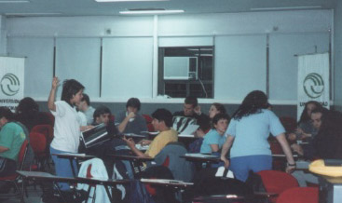

2nd Day of Classification Seminar: The participants were separated in 5 groups and had to establish the differences between the old and the new classification system for standing players as a way of theoretical test, the practical test consisted on the classification of 9 athletes by the groups.

5th Day: Introduction to the Sports for the disabled
UNLM Auditory

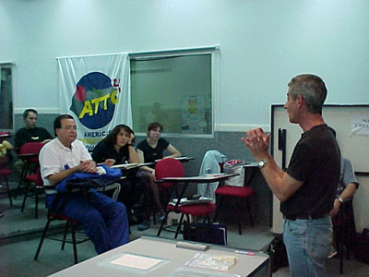

Prof. Marcelo Olleac, pathologies dissertation

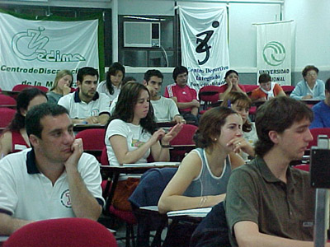

The treatment with people with disability
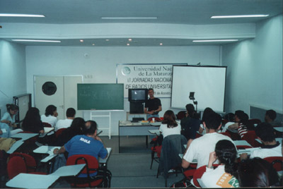

Explanation of the Paralympic Sports

6th Day: ATTC Coaching Seminar
UNLM Gymnasium

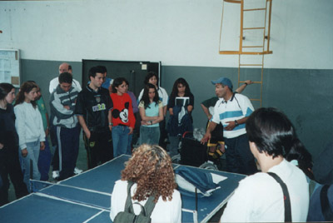

Leonardo Mariño, explanation about wheelchairs (parts, use, types)

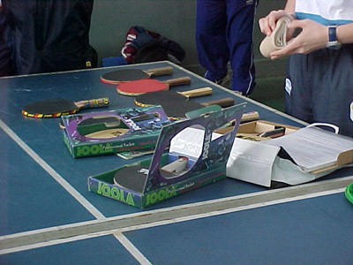

Alejandra Gabaglio, explanation about table tennis elements

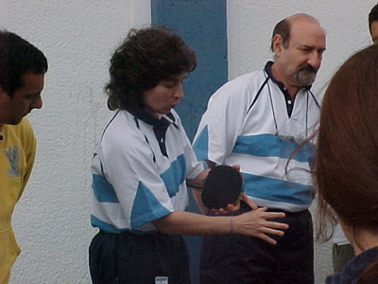

Handling of the racquet

6to Day: Seminar of Technical ATTC
UNLM Campus

Disability simulations for their understanding in the game

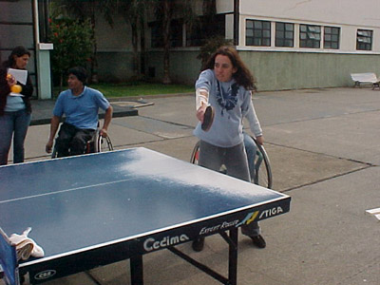

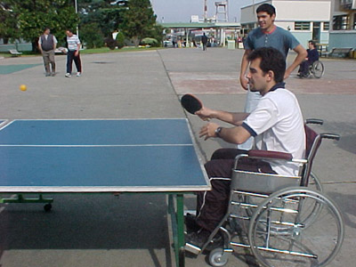

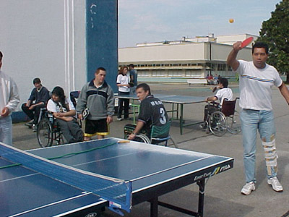
Practical exercises: How to program an initiation class?

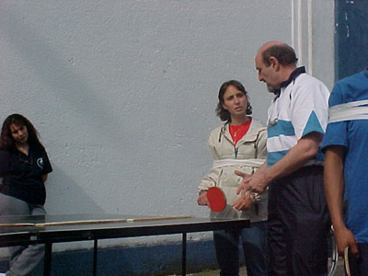

Alejandro Ceccati, teaching in the basic levels

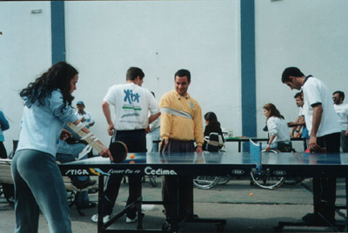

Games and exercises

7mo Day: Seminar of Technical ATTC
CEDIMA Training Gymnasium

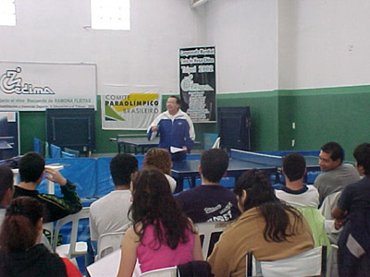

Benedito Rodrigues de Oliveira, trainings in the high-performance

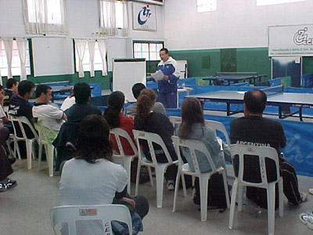

Spins, understanding and utilization

Seminars Closing

A funny exhibition between Leonardo Mariño Jr, Wheelchair National Team Coach and Paulo Guassardo, Buenos Aires able body 2001/02 Champion, was the closing of all the seminars before the delivery of diplomas. This kind of exhibition is used to initiate the work in a Table Tennis club for the disabled.

